**DAILY ONLINE ACTIVITIES SUMMARY**

|  |  |  |  |
| --- | --- | --- | --- |
| **Date:** | 05/07/2020 | **Name:** | JASLINE SHARON TAURO |
| **Sem & Sec** | 4th sem,  A Section | **USN:** | 4AL18CS029 |
| **Online Test Summary** | | | |
| **Subject** | NA | | |
| **Max. Marks** | NA | **Score** | NA |
| **Certification Course Summary** | | | |
| **Course** | Cloud Support Associate | | |
| **Certificate Provider** | AWS Educate | **Duration:** | 4 hrs |
| **Coding Challenges** | | | |
| **Problem Statement:**  **Given a string and we have to convert it to sentence case using C program.** | | | |
| **Status:** Executed | | | |
| **Uploaded the report in GitHub** | | YES | |
| **If yes Repository name** | | <https://github.com/jaslinesharontauro/C_Prgms> | |
| **Uploaded the report in slack** | | YES | |

Certification Course Details:

Today I have continued the course “Cloud Support Associate” by AWS Educate. In this course today I learnt about ‘Software Development’ and ‘Data and Databases’. I completed assessment of these modules and also completed the final assessment and final project. I have received a Badge for completion of this course.

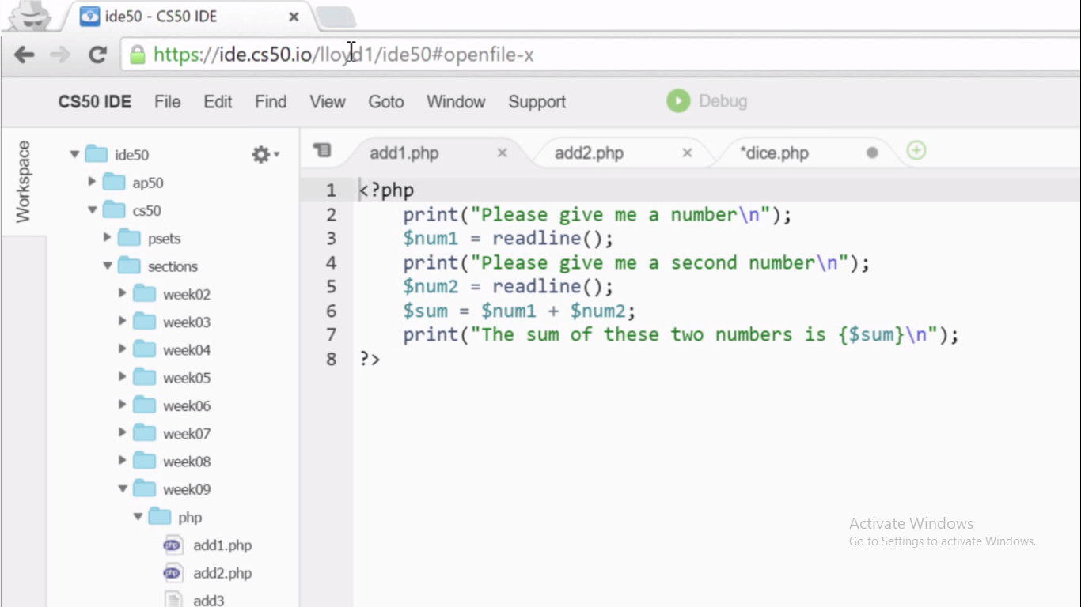

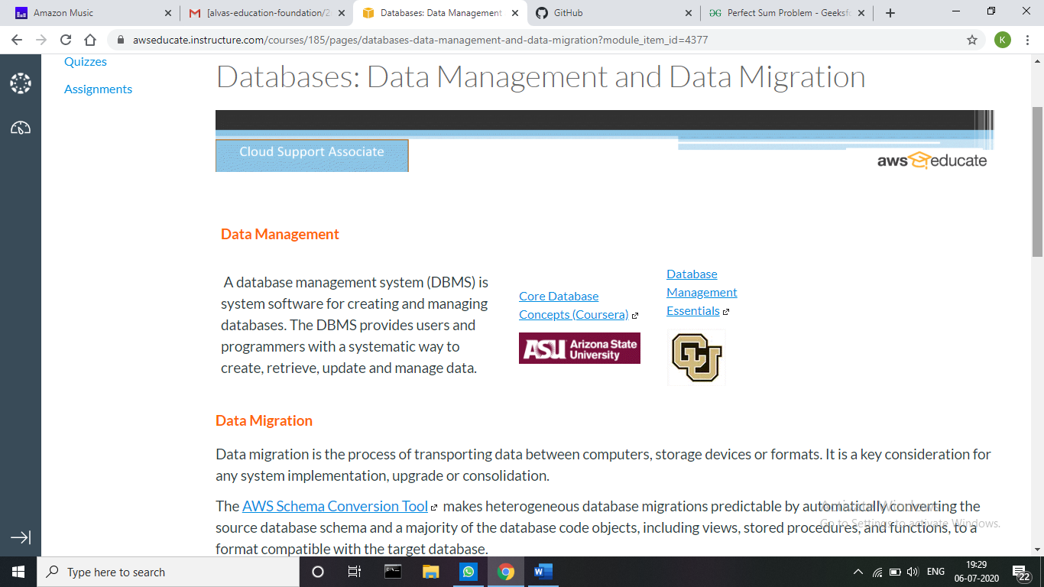

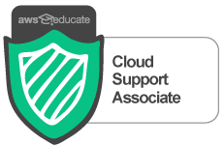

**Coding Challenges Details:**

**Problem statement:**

**Given a string and we have to convert it to sentence case using C program.**

**Example:**

Input string: "hello, how are you?"

Output:

Sentence case string is: "Hello, how are you?"

Input string: "hello. how are you?"

Output:

Sentence case string is: "Hello. How are you?"

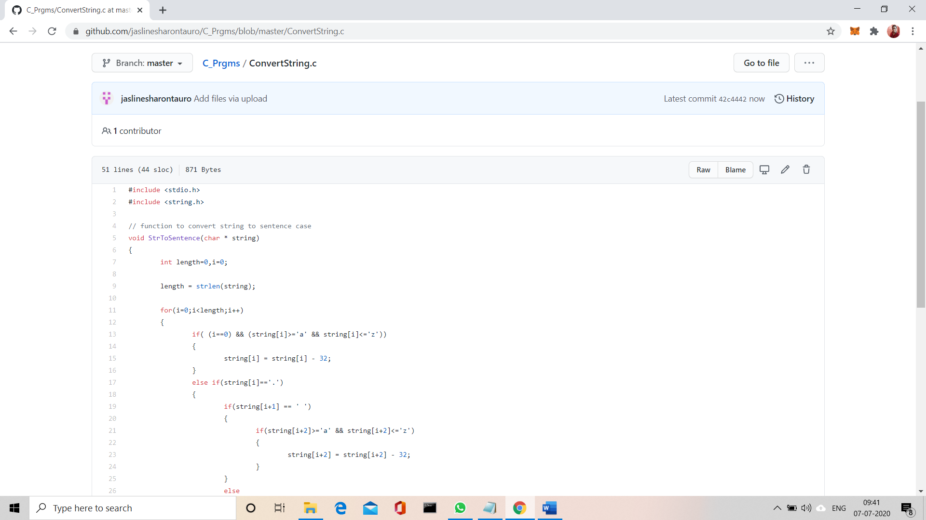

**Solution:** Uploaded it in GitHub